ASSIGNMENT SUBMISSION COVER SHEET
CSE25-217

ASSIGNMENT SUBMISSION COVER SHEET

Student Id: _______________________________

Student names: ____________________________

Student email: ____________________________

Cohort: 2026

Assignment title: SCIS WMD_2026 A01

Date of submission: _______________________

Programme of Study: _______________________

Year of Study: YEAR 1

Intellectual property statement

By checking the box below, I certify that this assignment is my own work and is free from plagiarism. I understand that the assignment may be checked for plagiarism by electronic or other means and may be transferred and stored in a database for the purposes of data-matching to help detect plagiarism. The assignment has not previously been submitted for assessment in any other unit or to any other institution.

I have read and understood the Botswana Accountancy College plagiarism guidelines policy.

☐ Agree

Signature: _______________________________

Date: ___________________________________Appendix 1: Assignment submission cover sheet

ASSIGNMENT SUBMISSION COVER SHEET

Student Id: _______________________________

Student names: ____________________________

Student email: ____________________________

Cohort: 2026

Assignment title: SCIS WMD_2026 A01

Date of submission: _______________________

Programme of Study: _______________________

Year of Study: YEAR 1

Intellectual property statement

By checking the box below, I certify that this assignment is my own work and is free from plagiarism. I understand that the assignment may be checked for plagiarism by electronic or other means and may be transferred and stored in a database for the purposes of data-matching to help detect plagiarism. The assignment has not previously been submitted for assessment in any other unit or to any other institution.

I have read and understood the Botswana Accountancy College plagiarism guidelines policy.

☐ Agree

Signature: _______________________________

Date: ___________________________________
Student Id:
PETER MPOFU
Student names:
cse25-217@thuto.bac.ac.bw
Student email:

Cohort: 2026

Assignment title: SCIS WMD_2026 A01

Date of submission:

Programme of Study:

Year of Study: YEAR 1
Intellectual property statement
By checking the box below, I certify that this assignment is my own work and is free from plagiarism. I understand that the assignment may be checked for plagiarism by electronic or other means and may be transferred and stored in a database for the purposes of data-matching to help detect plagiarism. The assignment has not previously been submitted for assessment in any other unit or to any other institution.
I have read and understood the Botswana Accountancy College plagiarism guidelines policy.
☐ Agree
Signature: _______________________________

Date: ___________________________________
AUTOMECHANICAL SPARES HUNTERS’ WEBSITE

WEBSITE SPECIFICATIONS

The Auto Mechanical Spares Hunters website is a business service platform designed to connect truck spare parts suppliers with spare parts shops. The platform focuses on solving the challenge where many spare shops struggle to find specialized truck parts, as this category is often overlooked in the market. Digital platforms have been shown to improve efficiency in supply chain management within the automotive industry.

The website acts as a bridge between suppliers and buyers, improving accessibility, efficiency, and business opportunities within the automotive spare parts industry.

Main Pages
The website consists of five (5) main pages:

• HOME PAGE (index.html)
Introduces the website and explains its purpose as a platform connecting suppliers and spare shops.

• ABOUT PAGE (about.html)
Explains the background of the business, its purpose, and how it benefits both suppliers and buyers.

• BROWSE PARTS PAGE (parts.html)
Displays different categories of truck spare parts such as:

- Engine Parts
- Brake Parts
- Electrical Parts
- Body Parts

• SUPPLIERS PAGE (suppliers.html)
Provides a list of available suppliers and their details.

• REQUEST PAGE (request.html)
Includes a form that allows users to request specific truck parts.

Functional Requirements

- Easy navigation across all pages using a navigation bar
- Clear display of truck spare parts categories
- Ability to connect users with suppliers
- User interaction through a request form
- Responsive design for different screen sizes

Non-Functional Requirements

- User-friendly interface
- Simple and consistent design
- Fast loading pages
- Accessibility across devices
- Reliable and secure interaction

OBJECTIVES

The Auto Mechanical Spares Hunters website aims to achieve the following objectives:
- To connect spare parts shops with truck spare parts suppliers
- To improve access to truck parts that are often overlooked
- To simplify the process of sourcing spare parts
- To create a central platform for suppliers and buyers
- To improve efficiency in the automotive spare parts industry

GOALS TO THE ORGANISATION

The website supports the organisation in the following ways:

Addressing a Market Gap
- The platform focuses on truck spare parts, which are often overlooked by many spare shops

Increasing Business Opportunities
- By connecting suppliers and buyers, the website increases potential transactions

Building Strong Networks
- The platform strengthens relationships between suppliers and spare shops

Enhancing Online Presence
- The website increases the company’s visibility and reach

Improving Efficiency
- Reduces time spent searching for suppliers manually

TARGET AUDIENCE

- Spare parts shop owners
- Mechanics
- Truck drivers
- Transport business owners
- Automotive businesses

TECHNICAL APTITUDE
The website is designed for users with basic to moderate technical skills.

Basic Users:
- Can browse websites
- Can click links and navigate pages
- Can fill out simple forms

Moderate Users:
- Comfortable using smartphones and computers
- Able to explore multiple pages and categories

INFORMATION DESIGN
The website follows a structured and user-centered design to ensure easy navigation and accessibility.

Layout Structure
Each page includes:
Header: Logo and navigation bar
Main Content: Organised sections with headings and images
Footer: Contact information and additional details

Design Principles
Clarity: Information is simple and easy to understand
Consistency: Same layout across all pages
Accessibility: Suitable for all users
Usability: Easy navigation and structure

TAXONOMY (Content Structure)

About q
- Purpose of the website
- Benefits to users
- Benefits to the organisation

Browse Parts
- Engine Parts
- Brake Parts
- Electrical Parts
- Body Parts

Suppliers
- Supplier profiles
- Contact details

User Interaction
- Request a part form

NAVIGATION STRUCTURE
The website uses a flat navigation structure, meaning all pages are easily accessible from the main menu.
- HOME
- ABOUT
- BROWSE PARTS
- SUPPLIERS
- REQUEST

SITE MAP
Home

About
Purpose of Website
Benefits to Users
Benefits to Organisation
Browse Parts
Engine Parts
Brake Parts
Electrical Parts
Body Parts

Suppliers
Supplier Profiles
Contact Details

Request a Part
Request Form

Contact
Email
Phone
Location

This ensures users can quickly access any section of the website.

WIREFRAME
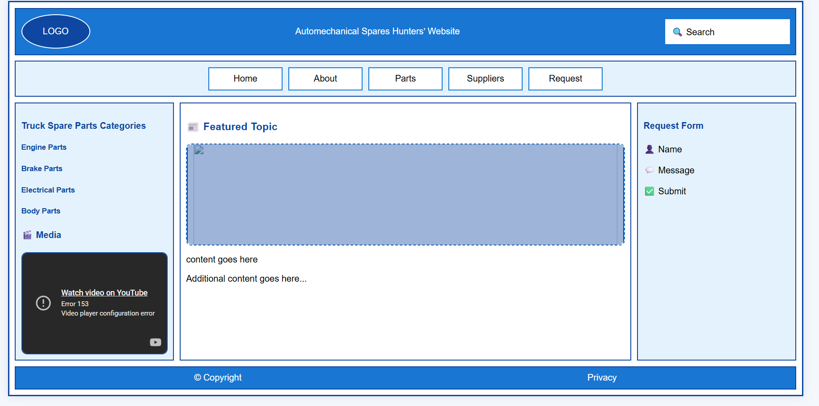

HOME PAGE
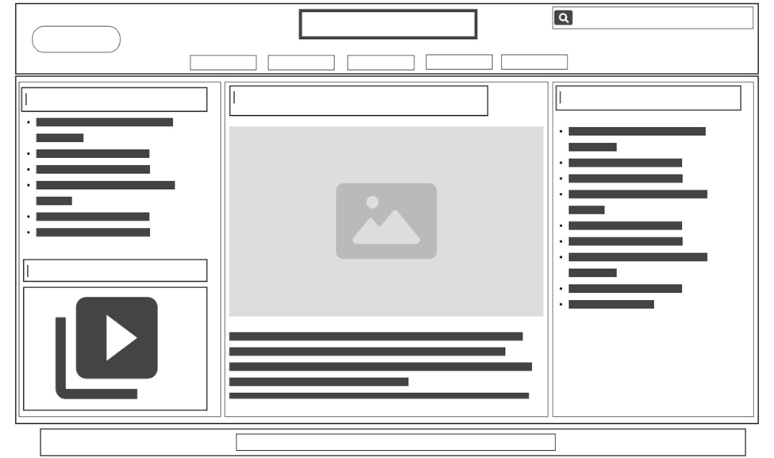

PARTS PAGE
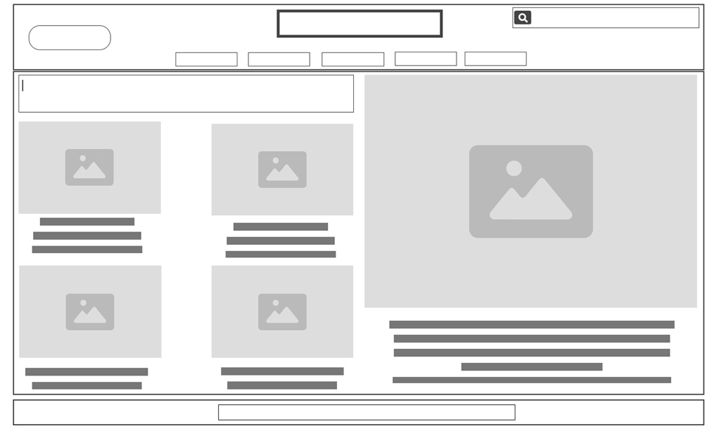

REQUESTS PAGE
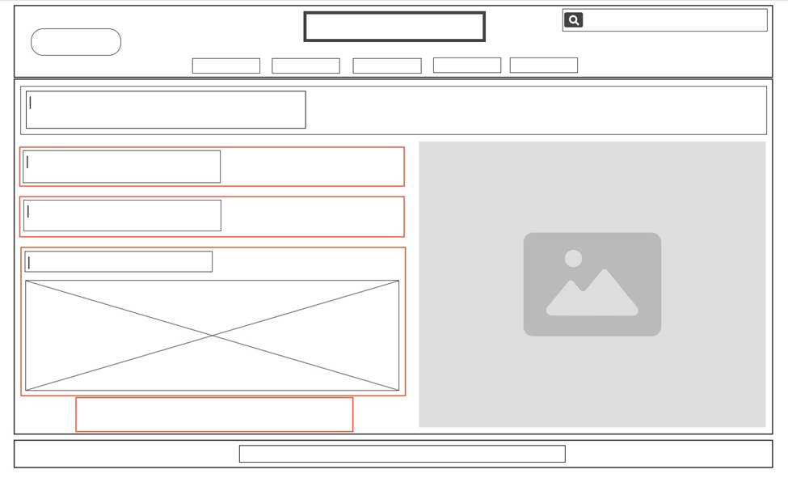

SUPPLIERS PAGE
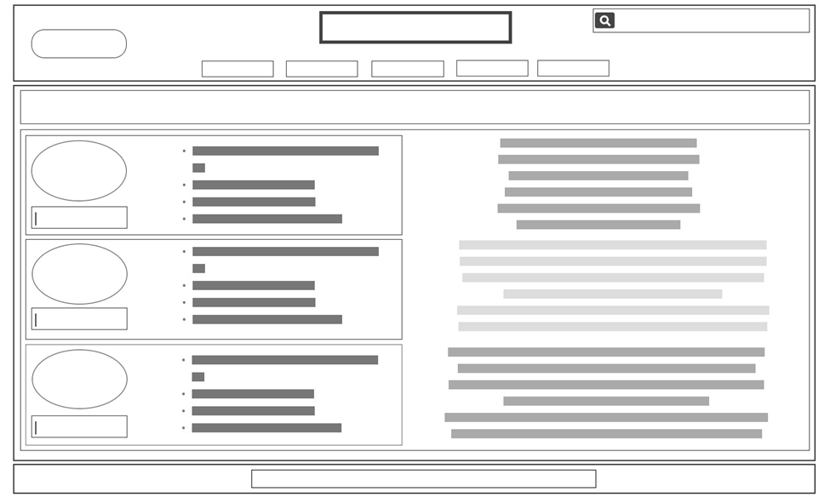

ABOUT US PAGE
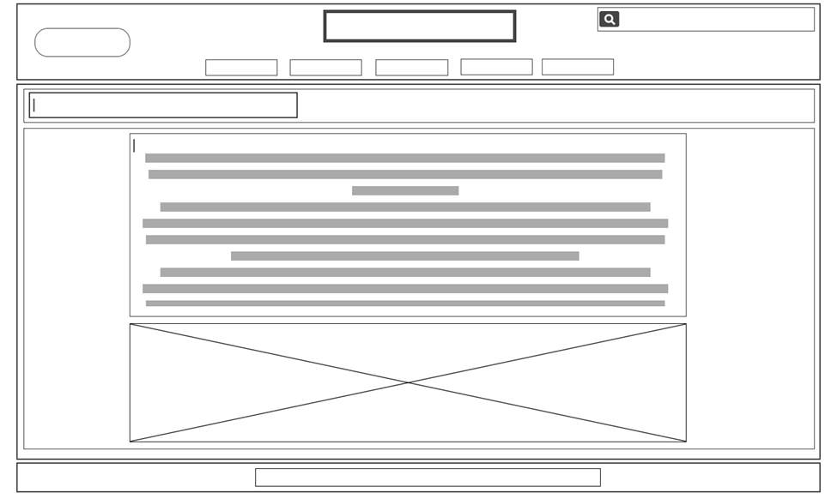

TECHNICAL BRIEF

The following tools and technologies will be used:

- HTML – For structuring the website content
- CSS – For styling and layout design
- Bootstrap – For responsive and mobile-friendly design
- Visual Studio Code – Development environment
- GitHub & GitHub Pages – Hosting and version control

